COMPANY SPONSORSHIP FORM
National Centre of Excellence for Workplace Learning (NACE)
Block D1, Level 4, Room 405
180 Ang Mo Kio Avenue 8, Singapore 569830

Course Title | A New Dimension in Workplace Learning to Drive Business Growth –  Innovating and Benchmarking with Germany’s Best-in-Class
Start Date (dd/mm/yy) | 26/10/19 | End Date (dd/mm/yy) | 31/10/19
Course Code | JC1D01
Course Fee (incl. GST) | Please refer to course website
(A) COURSE DETAILS

(B) COMPANY INFORMATION (* Mandatory)

Company Name*
Only for companies applying for the Enhanced Training Support Scheme. Please select only ONE option below:

Small-Medium Enterprise (SME): (Please complete Annex 1A and submit it together with this company sponsorship form)
Sole Proprietorship (SP): (Please complete Annex 1B and submit it together with this company sponsorship form)

Name of Contact Person* | Dr/Mr/Ms
Designation / Department
Mailing Address
 | Country |  |  |  |  |  |  |  |  |  |  | Postal Code
Tel No |  |  |  |  |  |  |  |  |  |  | Mobile
Fax No
E-mail Address*
Name of Billing Person: | Dr/Mr/Ms |  |  |  |  |  |  |  |  |  |  |  | Department
Billing Address:
 | Country |  |  |  |  |  |  |  |  |  |  | Postal Code
Billing Person's Contact Tel:

(C) APPLICANT INFORMATION

No. | Salutation | Name | Date of Birth | NRIC/FIN | Email Address
1. | Dr/Mr/Ms
2. | Dr/Mr/Ms
3. | Dr/Mr/Ms
4. | Dr/Mr/Ms
The company will sponsor the above applicant(s) for the course.

Name/Designation Signature/Date Company Stamp:

Annex 1A - DECLARATION FORM FOR ENHANCED TRAINING SUPPORT SCHEME
FOR SMALL & MEDIUM ENTERPRISES (SMEs)
Important Note:
- Please complete this form and attach it with the relevant UEN printout (refer to Annex 2 for instructions).
- Please submit this form as part of your supporting documents during course application OR to your Course Co-ordinator/Manager if the course has already commenced.
- NYP reserves the right to reject the application if it is incomplete.

Name of Trainee(s) |  |  |  |  | NRIC/FIN no. of Trainee(s)  (last 3 numeric digits and alphabet)
Training Institution | Nanyang Polytechnic
Course Title | A New Dimension in Workplace Learning to Drive Business Growth –  Innovating and Benchmarking with Germany’s Best-in-Class
Course Commencement Date | 26/10/19
Module Name | Please tick below module(s). [For Single Module(s) application only]
Module Commencement Date where applicable | 26/10/19 [For Single Module(s) application only]
Please select the options that the trainee is applying for [either (i) OR (ii)]:
*Note: Module title may be subject to changes or replaced by another module where applicable.
- Applicable to trainee who is applying to study Full Course |  |  | - Applicable to trainee who is applying to study Single Module(s)
Modular Certificate / Post-Diploma Certificate in XXX |  |  | Modules title: Workplace Learning Blueprint Development Training
Modular Certificate / Post-Diploma Certificate in XXX
Full Entity Name (SME): |  |  |  |  | UEN Number:
- Declaration of Employer Small and Medium Enterprise (SME) Status and full sponsorship for course/module(s) applied
This form serves to declare that the named trainee is currently an employee of the above entity. And that the above entity is an organisation registered or incorporated in Singapore and satisfy the following conditions during period of application:

1. At least 30% local shareholding AND
Please tick 2a. and/or 2b.

2a. Group¹ annual sales turnover² of not more than $100 million OR

2b. Group employment size³ of (not more than 200)

¹Group tracing:

Please fill up
- All corporate shareholder(s) holding more than 50% of total shareholding of the company and any subsequent corporate parents.
- All subsidiaries of the company.
² Annual sales turnover refers to the revenue or sales turnover stated on the company’s income statement.
³ A company should include in its employment size any persons employed under a contract of service in accordance to the Employment Act. This is regardless of the nationality of the employee.
In the event that the above entity no longer meet the above conditions and/or sponsoring the named trainee, the entity must inform Nanyang Polytechnic immediately in writing as they will no longer enjoy the enhanced training support for SMEs.

NOTE: For the purpose of enhanced training support application under this scheme, SMEs include Associations, Charitable Organisations (VWOs), Societies who are registered/ incorporated in Singapore.

- Check list for enclosed compulsory supporting documents
Recent printout from UEN website as evidence that the above entity is registered in Singapore with a valid UEN number (must be dated not more than 1 week after course application closing date). (See sample printout in Annex 2).
- Sponsoring company details and endorsement
Email address of HR Office (or equivalent)
Contact no. of HR Office (or equivalent)
Name & Designation of signatory: |  | Signature: |  | Date: |  | Company Stamp:

Annex 1B - DECLARATION FORM FOR ENHANCED TRAINING SUPPORT SCHEME
FOR SOLE PROPRIETORSHIP (SP)
Important Note:
- Please complete this form and attach it with the relevant UEN printout (refer to Annex 2 for instructions).
- Please submit this form as part of your supporting documents during course application OR to your Course Co-ordinator/Manager if the course has already commenced.
- NYP reserves the right to reject the application if it is incomplete.

Name of Trainee(s) |  |  |  |  | NRIC/FIN no. of Trainee(s)  (last 3 numeric digits and alphabet)
Training Institution | Nanyang Polytechnic
Course Title | A New Dimension in Workplace Learning to Drive Business Growth –  Innovating and Benchmarking with Germany’s Best-in-Class
Course Commencement Date | 26/10/19
Module Name | Please tick below module(s). [For Single Module(s) application only]
Module Commencement Date where applicable | 26/10/19 [For Single Module(s) application only]
Please select the options that the trainee is applying for [either (i) OR (ii)]:
*Note: Module title may be subject to changes or replaced by another module where applicable.
- Applicable to trainee who is applying to study Full Course |  |  | - Applicable to trainee who is applying to study Single Module(s)
Modular Certificate / Post-Diploma Certificate in |  |  | Modules title: Workplace Learning Blueprint Development Training
Modular Certificate / Post-Diploma Certificate in
Full Entity Name (Sole-proprietorship): |  |  | UEN Number:
- Declaration of Employer Sole-Proprietorship Status and full sponsorship for course/module(s) applied
This form serves to declare that the named trainee is currently an employee of the above entity. And that the above entity is an organisation registered or incorporated in Singapore as a sole-proprietorship

with employee size of (not more than 200) and is active during period of course application.

In the event that the above entity no longer meet the above conditions and/or sponsoring the named trainee, the entity must inform Nanyang Polytechnic immediately in writing as they will no longer enjoy the enhanced training support for SMEs.
Please fill up
NOTE: For the purpose of enhanced training support application under this scheme, SMEs include Associations, Charitable Organisations (VWOs), Societies who are registered/ incorporated in Singapore.
- Check list for enclosed compulsory supporting documents
Recent printout from UEN website as evidence that the above entity is registered in Singapore with a valid UEN number (must be dated not more than 1 week after course application closing date). (See sample printout in Annex 2)
- Sponsoring company details and endorsement
Email address of Sole-proprietor
Contact no. of Sole-proprietor
Name & Designation of signatory: |  | Signature: |  | Date: |  | Company Stamp:

Annex 2

- Steps to find and print UEN printout
Step 1: Go to website: www.uen.gov.sg
Step 2: Enter your company Entity Name or UEN Number in the box (highlighted in red below)
Step 3: Click on the “Search” button to get the search results
Step 4: Print the search results and attach printout to declaration

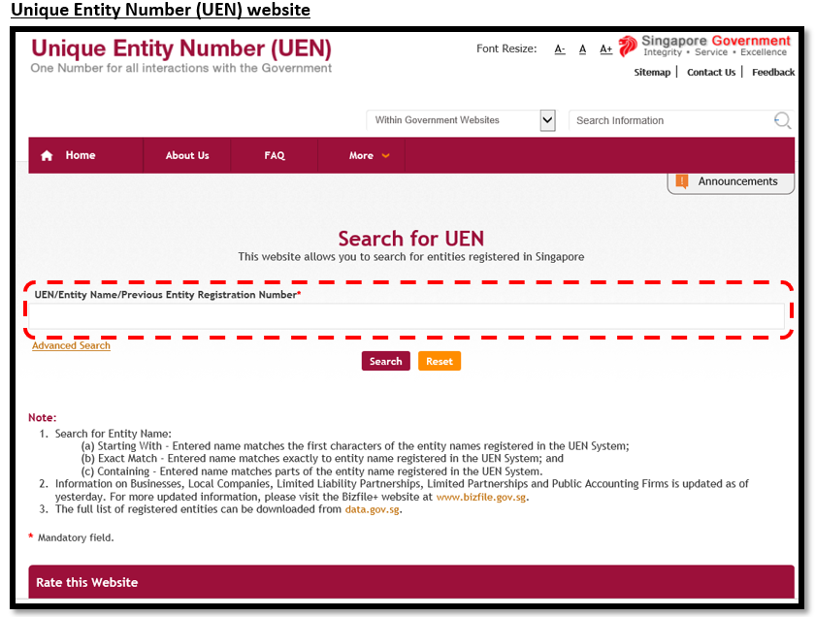

- Sample of required UEN printout
